BUILD AN EVENT MANAGEMENT SYSTEM USING SALESFORCE

1.INTRODUCTION

Event management is the process of analyzing,planning,marketing,producing and evaluating an event.it is a different way of promoting a product,service or idea.

1.1 OVER VIEW

This process spans from the very beginning of planning all the way to post-event strategizing.At the start,an event manager planning decisions,such as the time,location and theme of their events.

1.2 purpose

Hiring an event planner to conceptualize,prepare for,and coordinates an event alleviates much of the stress and pressure,allowing you to relax and look forward to your event.

2. PROBLEM DEFINITION & DESIGN THINKING

2.1 EMPATHY MAP

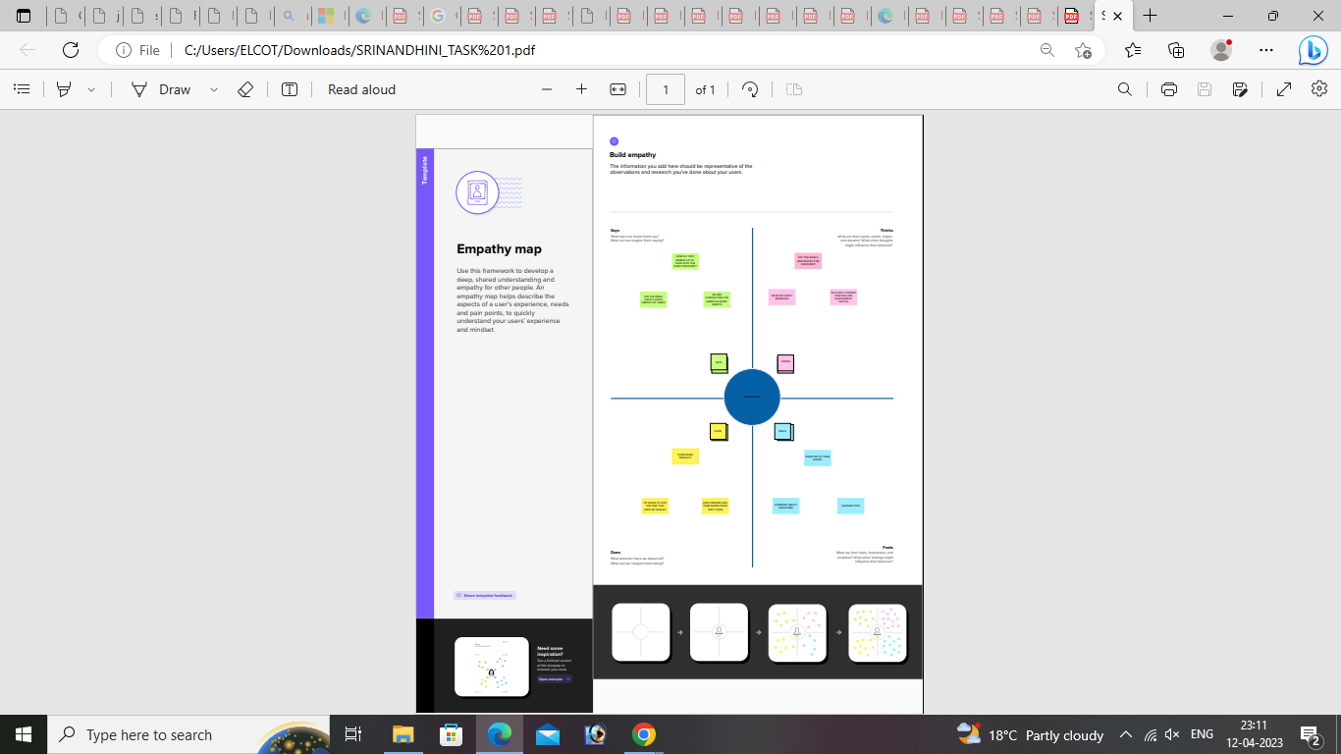

2.2 IDEATION & BRAINSTORMING

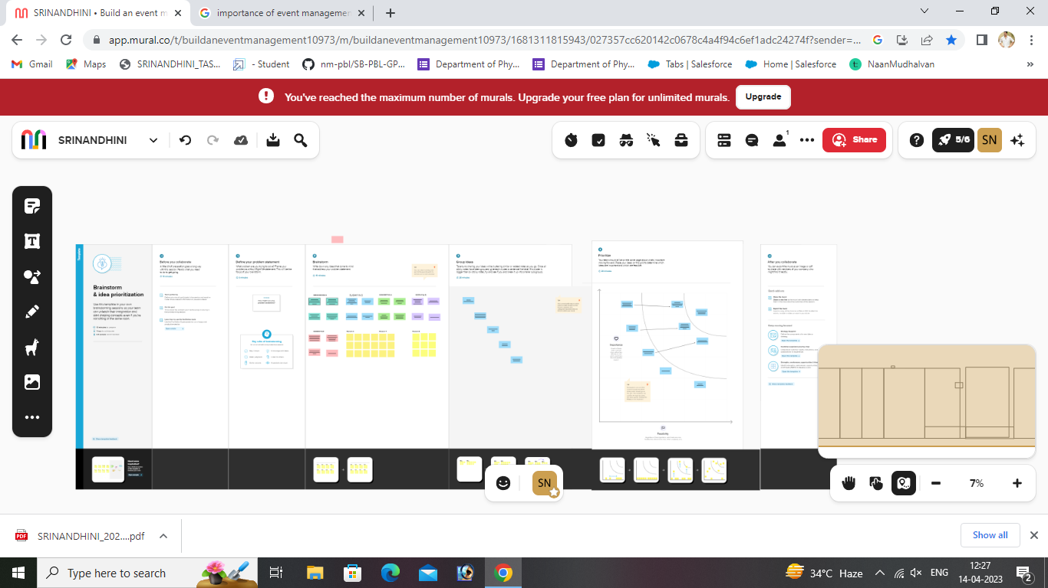

3.RESULT

3.1 DATA MODEL:

| Object name | Fields in the object |
| --- | --- |
| Object 1 | | Field label | Data type | | --- | --- | | city | text | | Start date | date/time | | End date | date/time | |
| Object 2 | | Field label | Data type | | --- | --- | | Auto number | id | | phone | phone | | Email | Email | | tickets | picklist | | Master-detail relationship | Event | |

3.2 ACTIVITY & SCREENSHOT

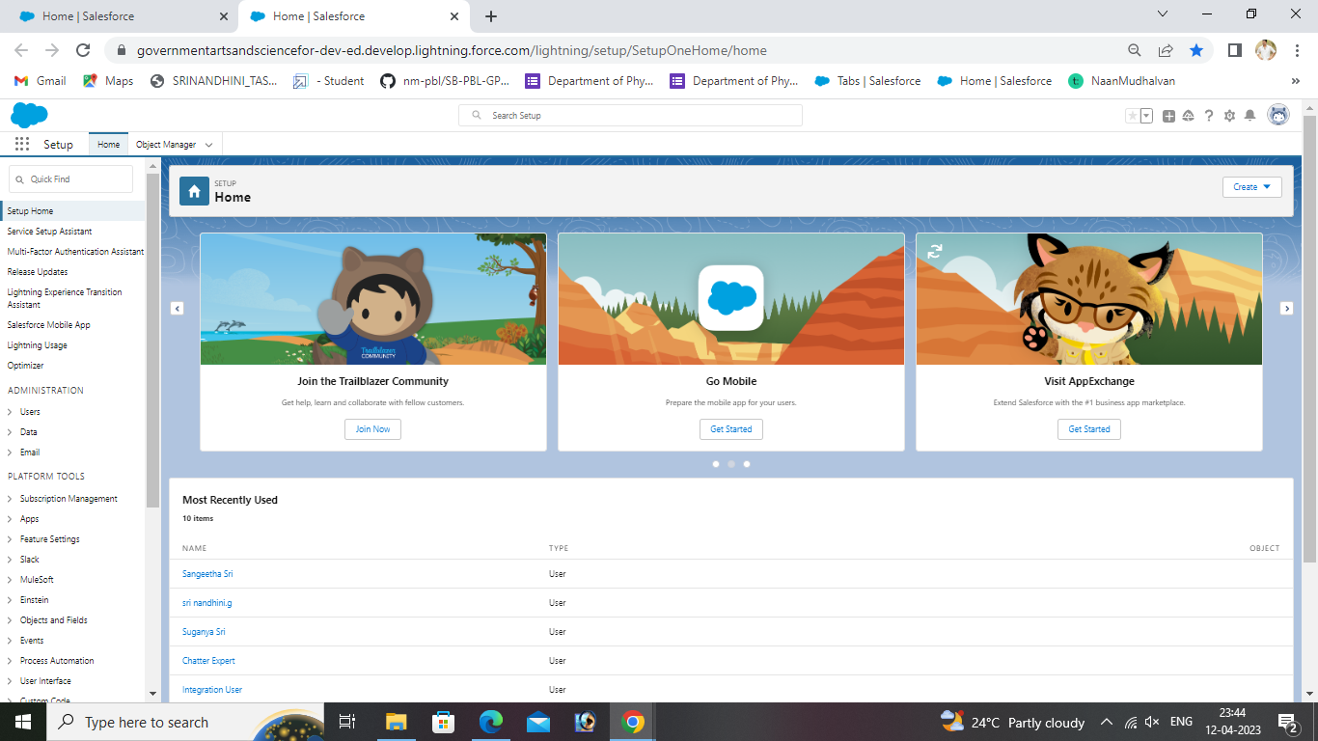

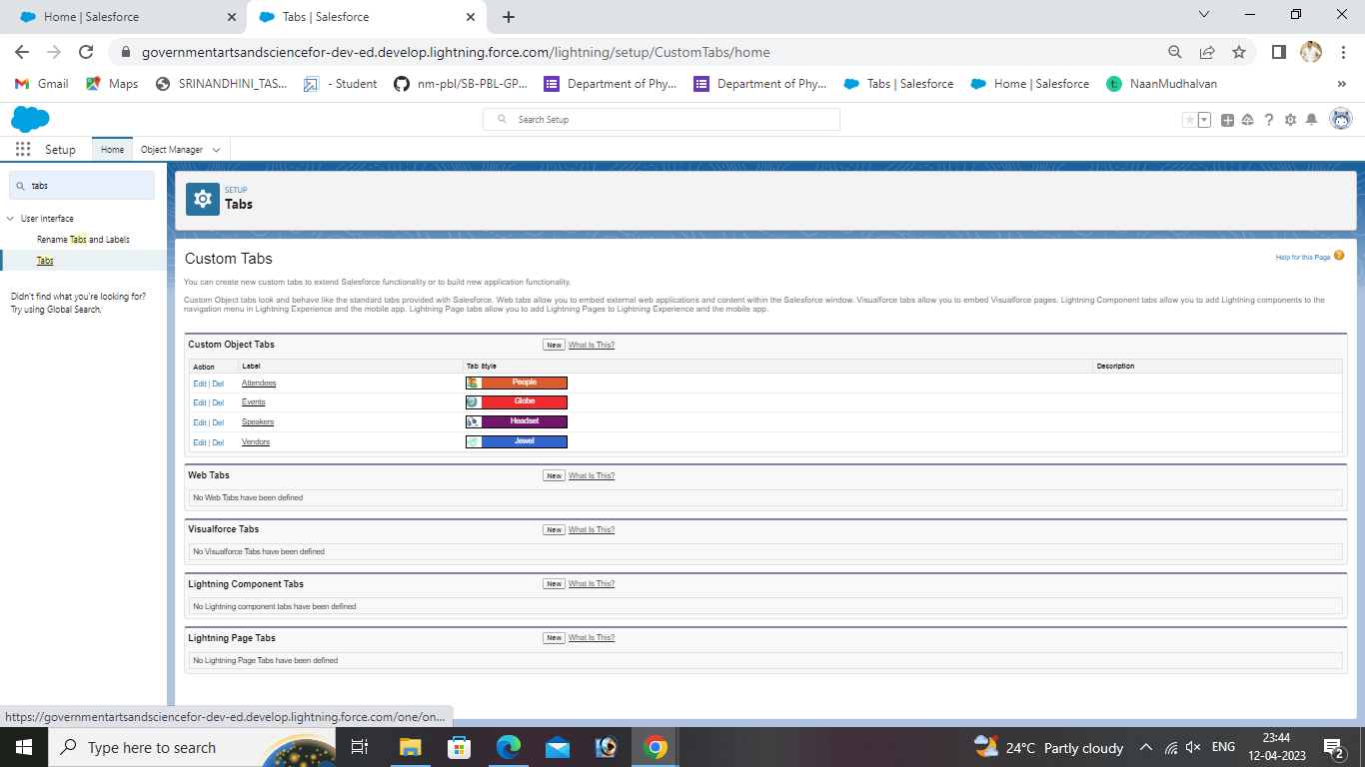

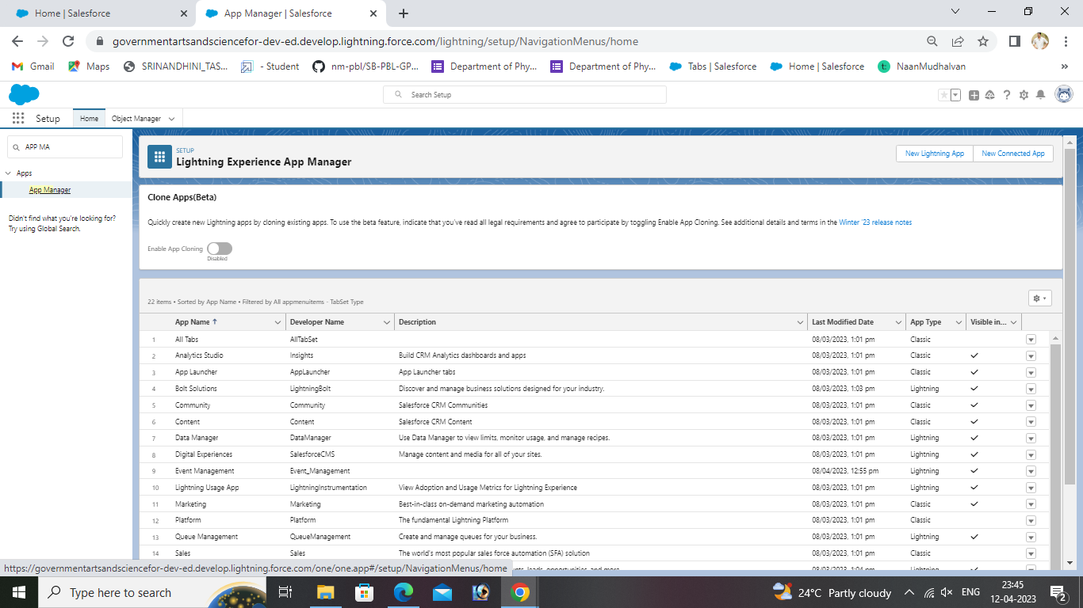

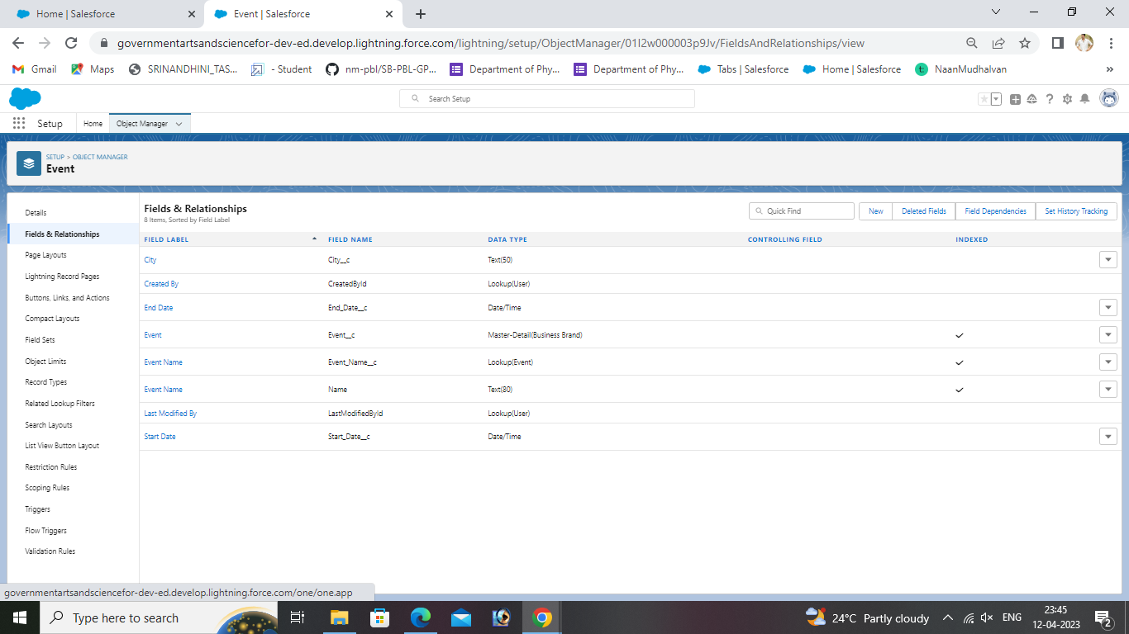

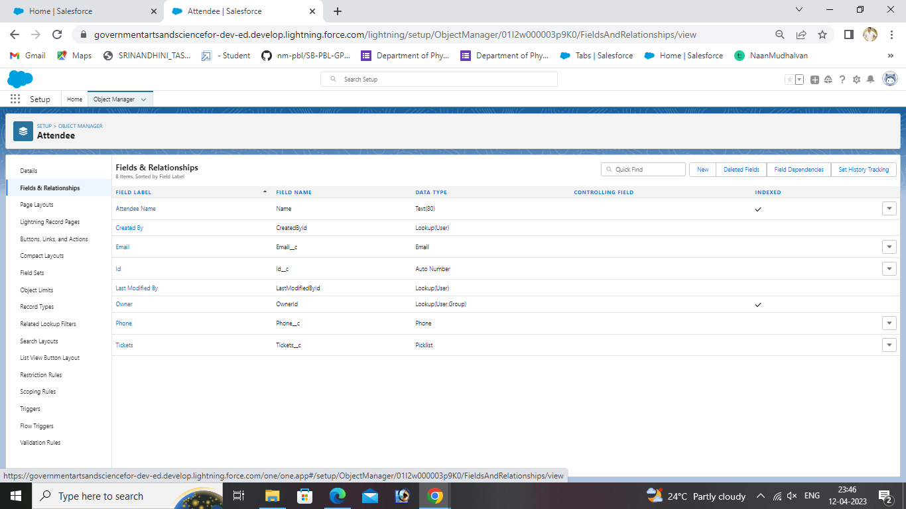



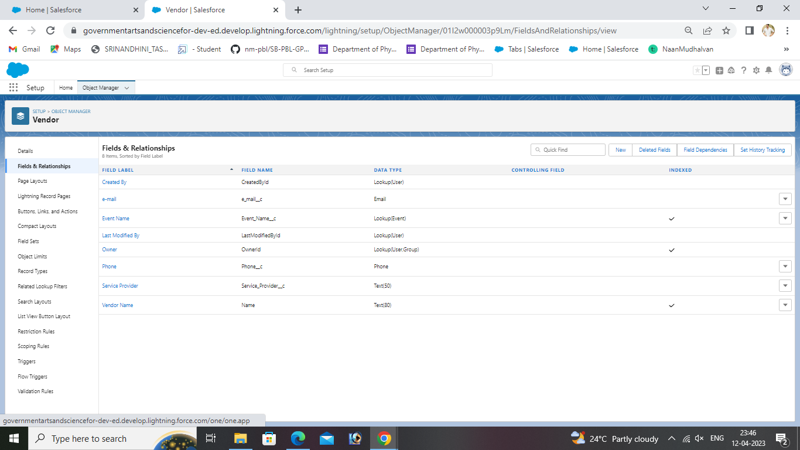





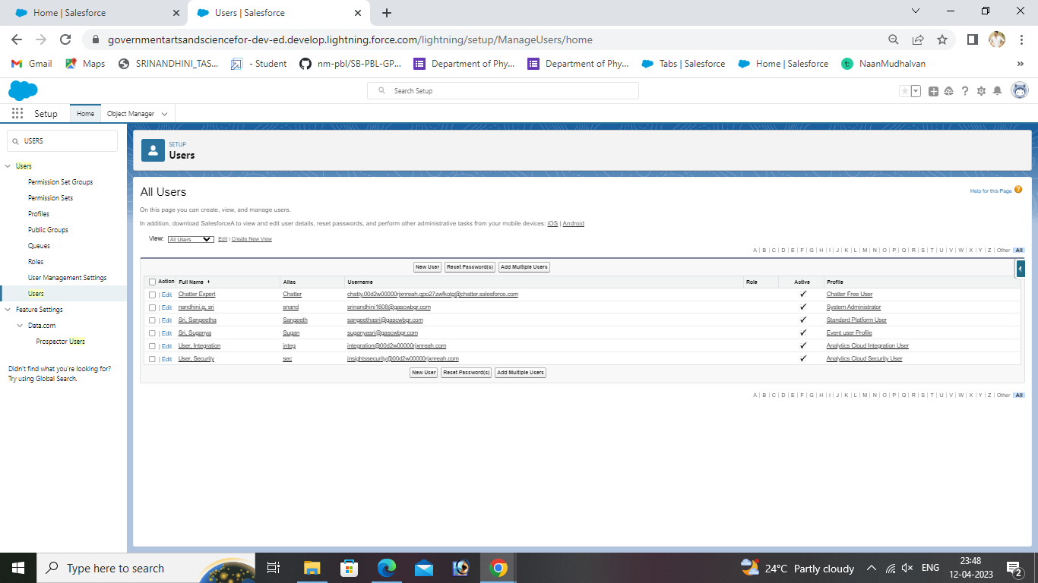

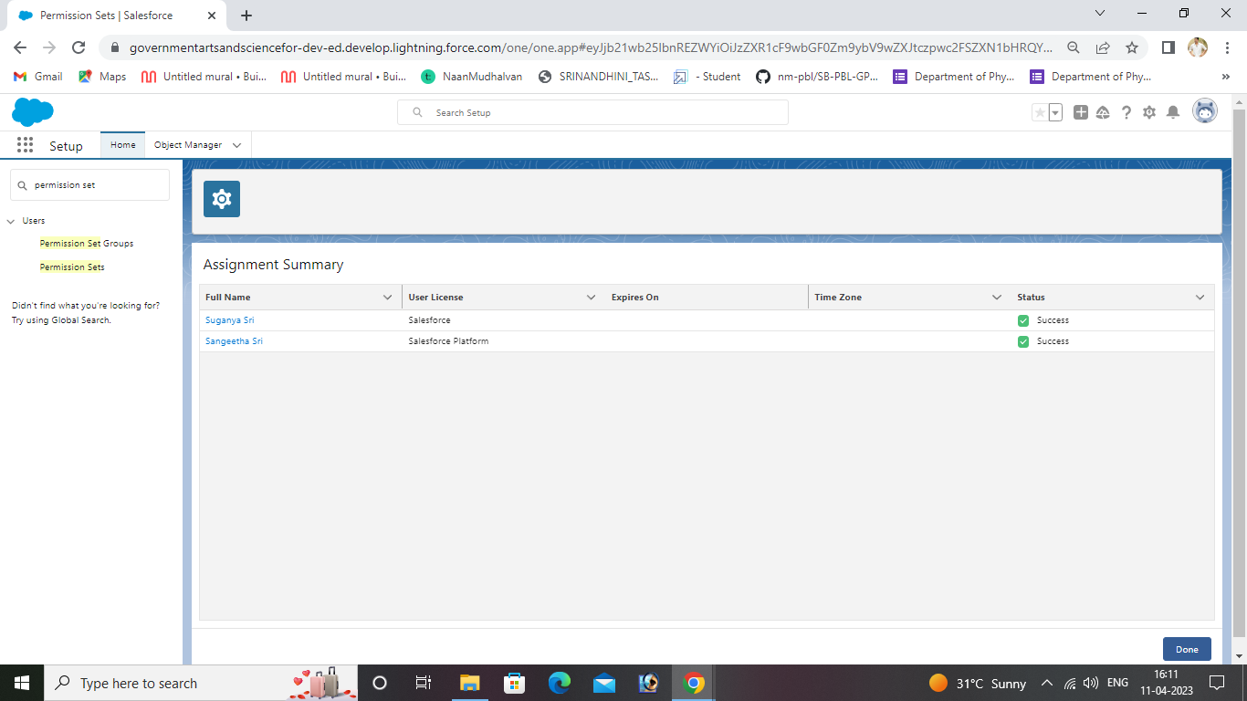

4.TRAILHEAD PROFILE PUBLIC URL

TEAM LEAD -[trailblazer.me/id/snandhinig](https://trailblazer.me/id/snandhinig)

TEAM MEMBER 1-[trailblazer.me/id/ssuganya8](https://trailblazer.me/id/ssuganya8)

TEAM MEMBER 2-<https://trailblazer.me/id/ssangeetha25>

TEAM MEMBER 3-[trailblazer.me/id/ssoniya8](https://trailblazer.me/id/ssoniya8)

TEAM MEMBER 4-[trailblazer.me/id/sandr1171](https://trailblazer.me/id/sandr1171)

4. ADVANTAGES

Opportunity for creativity.

Ability to work on different events.

Planning the layouts of tables,chairs and other furniture.

Finding sponsors to fund the event.

Organizing transportation.

Resolving issues during the event.

5.DISADVANTAGES

Sponsor may request changes in rules,equipment,start times etc.

These are not always suited to the performers.

6.APPLICATIONS

Sell event tickets

Targeted digital marketing

Enables effective communication

Establish an attendee network

Event apps help with branding

7.CONCLUSION

Event management system is users friendly and cost effective system,it is customized with actives related with event management life-cycle.

8.FUTURE SCOPE

It involves management creation and development of events such as corporate conferences,wedding,festivals,formal parties etc.

Graduate degree,diploma and certificate courses in event management: Aspirants who wish to get admission in event management course colleges/universities at the UG level .

PG courses in event management for postgraduate courses offered in event management,candidates should be graduates from recognised institutes aspirants from any stream are eligible to purse postgraduate level course in event management.candidates with a mass communication academic background would be preferred.